Parent | Child | GrandChild | GreatGrandChild | 2 x GreatGrandChild | 3 x GreatGrandChild
Level 1 | Level 2 | Level 3 | Level 4 | level 5 | Level 6
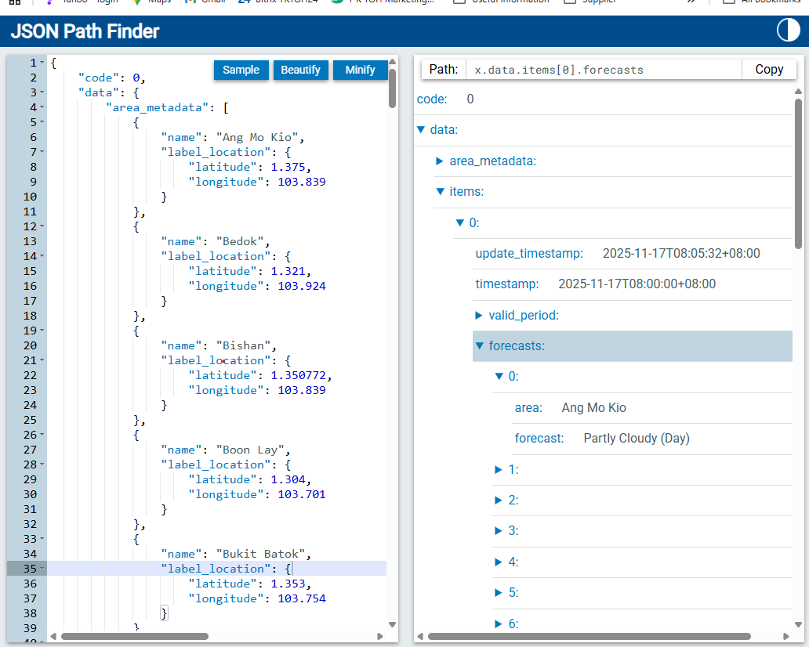
x.code
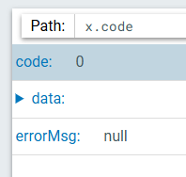
x.data
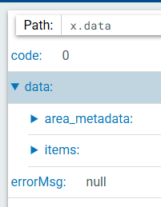
 | x.data.area_metadata
 | 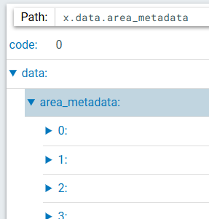
 |  | x.data.area_metadata[0]
 |  | 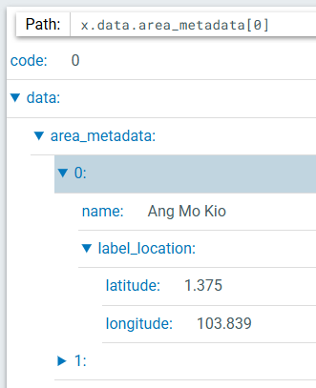
 |  |  | x.data.area_metadata[0].name
 |  |  | 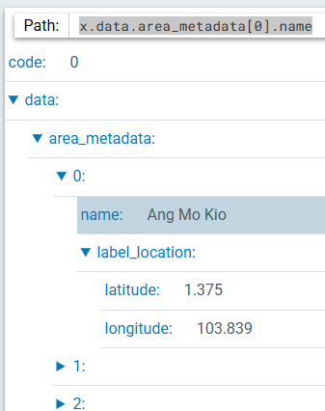
 |  |  | x.data.area_metadata[0].label_location
 |  |  | 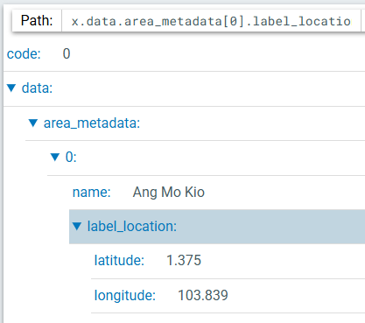
 |  |  |  | x.data.area_metadata[0].label_location.latitude
 |  |  |  | 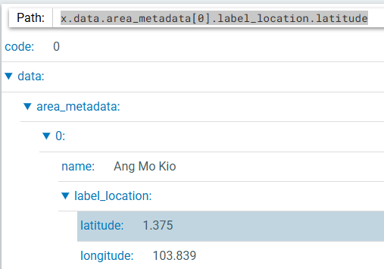
 |  |  |  | x.data.area_metadata[0].label_location.longitude
 |  |  |  | 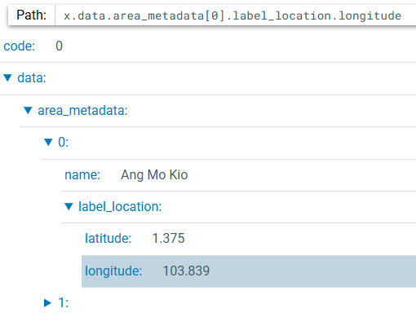
 | x.data.items
 | 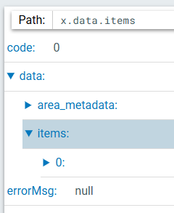
 |  | x.data.items[0]
 |  | 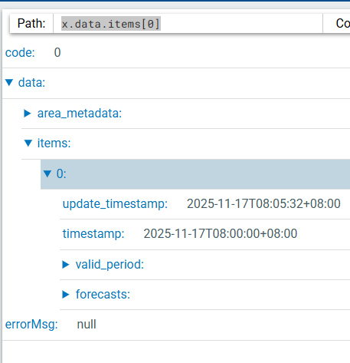
 |  |  | x.data.items[0].update_timestamp
 |  |  | 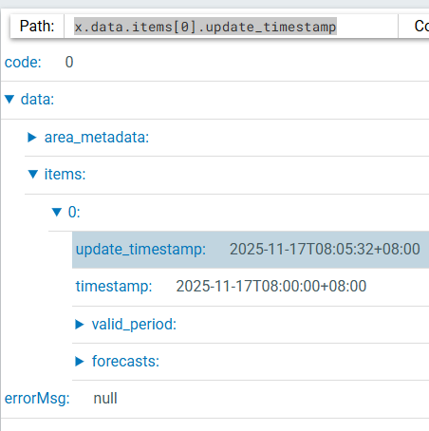
 |  |  | x.data.items[0].timestamp
 |  |  | 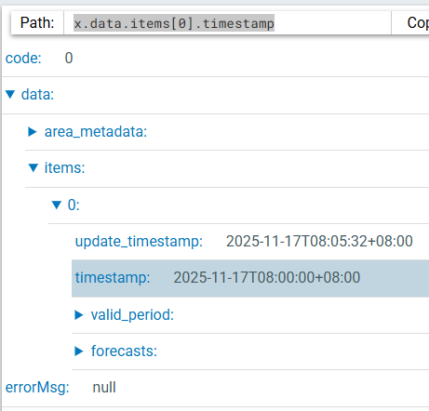
 |  |  | x.data.items[0].valid_period
 |  |  | 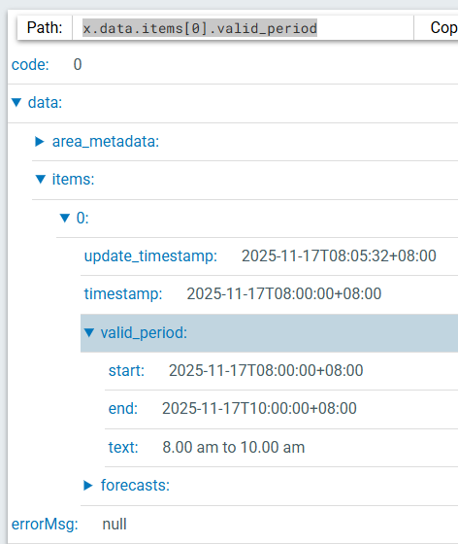
 |  |  |  | x.data.items[0].valid_period.start
 |  |  |  | 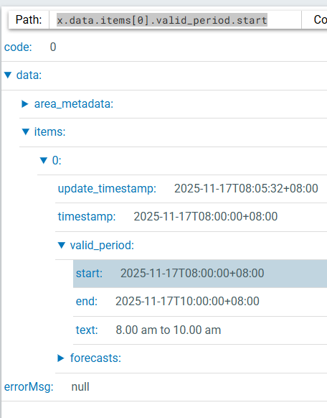
 |  |  |  | x.data.items[0].valid_period.end
 |  |  |  | 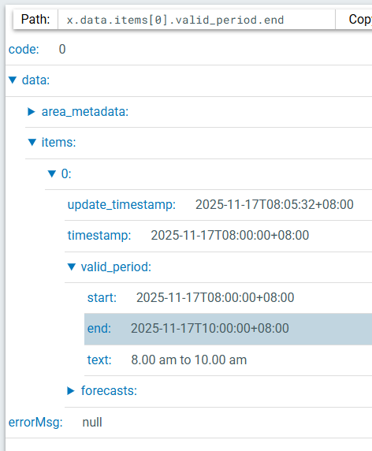
 |  |  |  | x.data.items[0].valid_period.text
 |  |  |  | 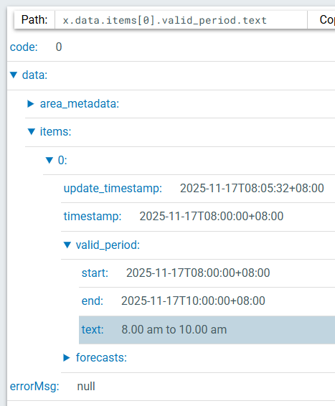
 |  |  | x.data.items[0].forecasts
 |  |  | 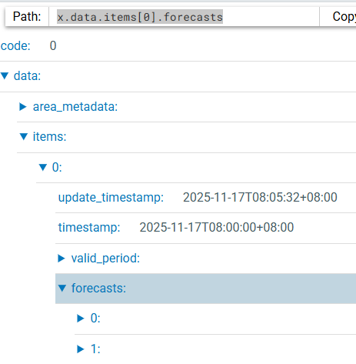
 |  |  |  | x.data.items[0].forecasts[0]
 |  |  |  | 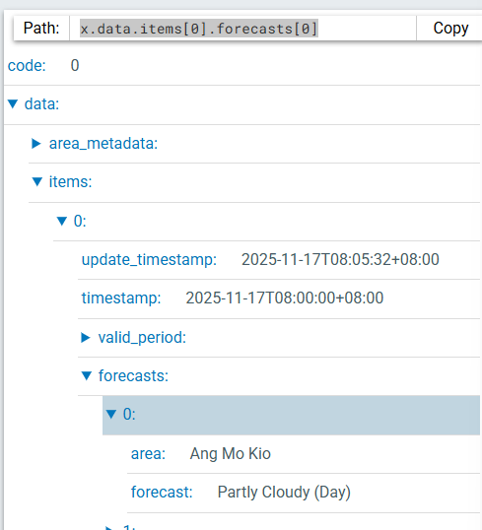
 |  |  |  |  | x.data.items[0].forecasts[0].area
 |  |  |  |  | 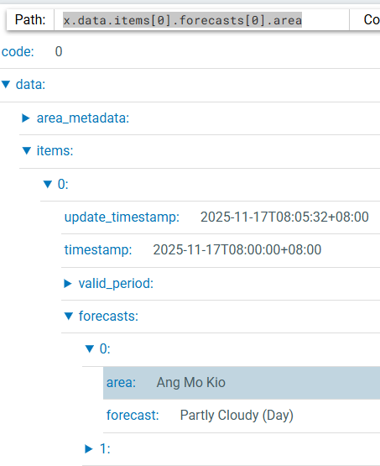
 |  |  |  |  | x.data.items[0].forecasts[0].forecast
 |  |  |  |  | 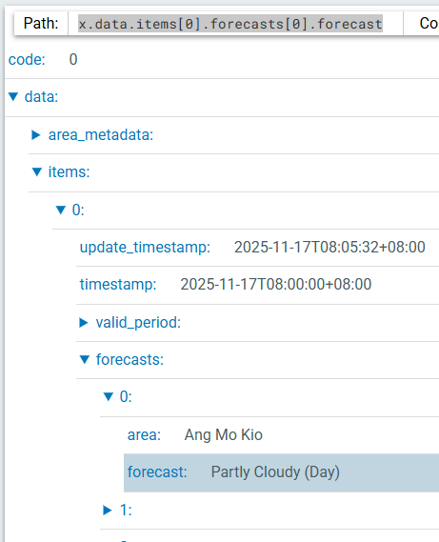
 | x.errorMsg
 | 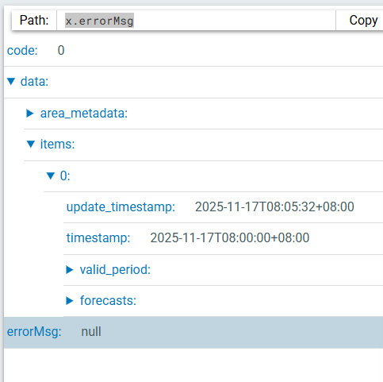

Parent | Child | GrandChild | GreatGrandChild | 2 x GreatGrandChild | 3 x GreatGrandChild
Level 1 | Level 2 | Level 3 | Level 4 | level 5 | Level 6
x.code
x.data
 | x.data.area_metadata
 |  | x.data.area_metadata[0]
 |  |  | x.data.area_metadata[0].name
 |  |  | x.data.area_metadata[0].label_location
 |  |  |  | x.data.area_metadata[0].label_location.latitude
 |  |  |  | x.data.area_metadata[0].label_location.longitude
 | x.data.items
 |  | x.data.items[0]
 |  |  | x.data.items[0].update_timestamp
 |  |  | x.data.items[0].timestamp
 |  |  | x.data.items[0].valid_period
 |  |  |  | x.data.items[0].valid_period.start
 |  |  |  | x.data.items[0].valid_period.end
 |  |  |  | x.data.items[0].valid_period.text
 |  |  | x.data.items[0].forecasts
 |  |  |  | x.data.items[0].forecasts[0]
 |  |  |  |  | x.data.items[0].forecasts[0].area
 |  |  |  |  | x.data.items[0].forecasts[0].forecast
 | x.errorMsg

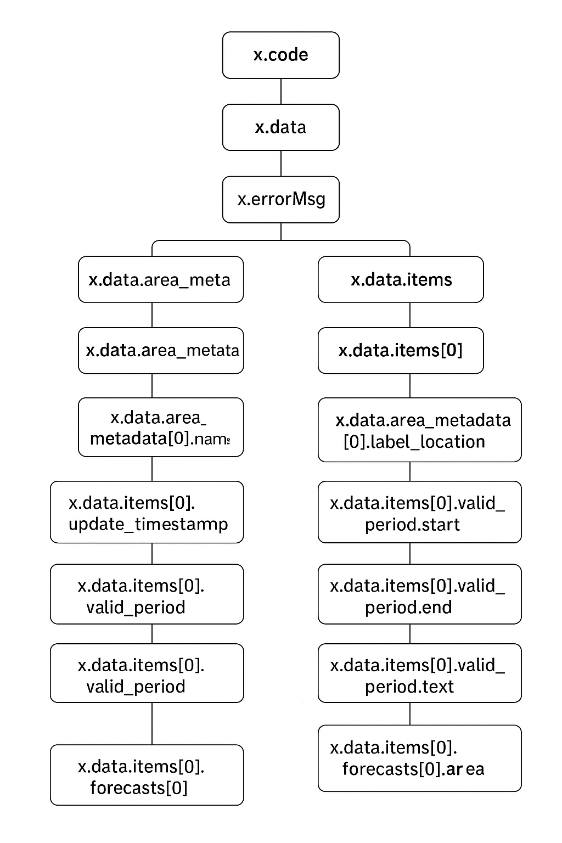

Table of 2-hour Weather Forecast for 47 regions using API from
https://api-open.data.gov.sg/v2/real-time/api/two-hr-forecast
Name | Latitude | Longitude | forecast
x.data.area_metadata[0].name | x.data.area_metadata[0].label_location.latitude | x.data.area_metadata[0].label_location.longitude | x.data.items[0].forecasts[0].forecast
Ang Mo Kio | 1.375 | 103.839 | Partly Cloudy (Day)
Bedok | 1.321 | 103.924 | Partly Cloudy (Day)
….
….

Table of Time Stamp using API from
https://api-open.data.gov.sg/v2/real-time/api/two-hr-forecast
Start | x.data.items[0].valid_period.start
End | x.data.items[0].valid_period.end
Text | x.data.items[0].valid_period.text

`

Table of 2-hour Weather Forecast for 47 regions using API from
https://api-open.data.gov.sg/v2/real-time/api/two-hr-forecast
Name | Latitude | Longitude | forecast
x.data.area_metadata[0].name | x.data.area_metadata[0].label_location.latitude | x.data.area_metadata[0].label_location.longitude | x.data.items[0].forecasts[0].forecast
Ang Mo Kio | 1.375 | 103.839 | Partly Cloudy (Day)
Id code created | Id code created | Id code created | Id code created
Bedok | 1.321 | 103.924 | Partly Cloudy (Day)
Id code created | Id code created | Id code created | Id code created
….

